**SQL REINFORCEMENT PROJECT**

**i) Count the total number of records in each table of the database:**

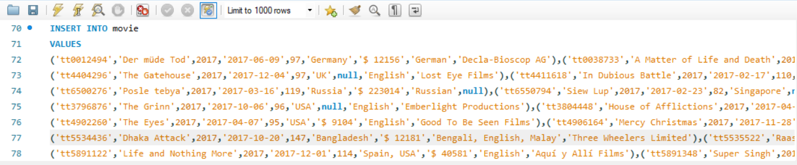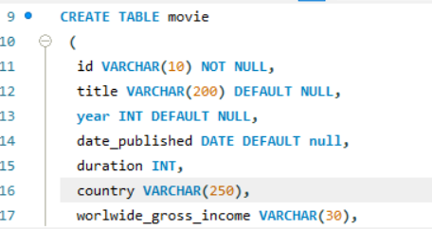

**  
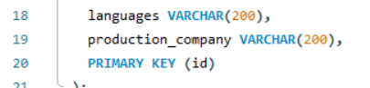**

OUTPUT:

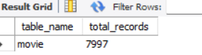













**ii) Identify which columns in the movie table contain null values:**











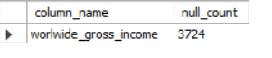













**iii) Determine the total number of movies released each year, and analyze how the trend changes month-wise**

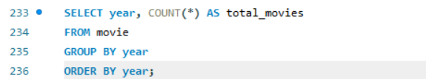 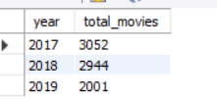

**iv) How many movies were produced in either the USA or India in the year 2019?**

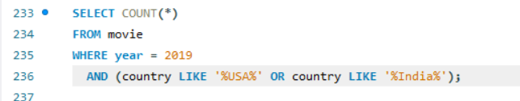

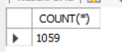

**v) List the unique genres in the dataset, and count how many movies belong exclusively to one genre.**

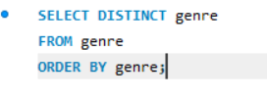

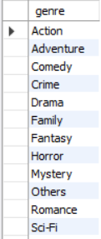

**vi) Which genre has the highest total number of movies produced?**

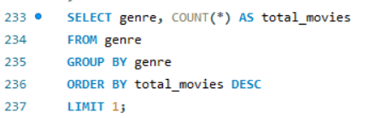

**vii) Calculate the average movie duration for each genre**

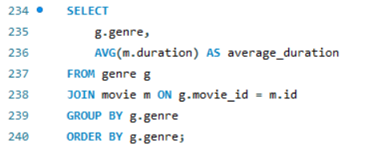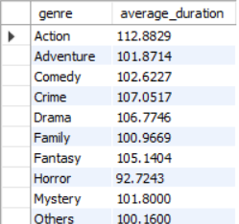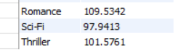

**viii) Identify actors or actresses who have appeared in more than three movies with an average rating below 5.**

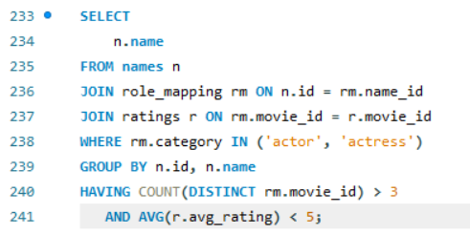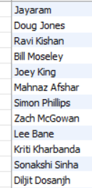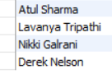

**ix)Find the minimum and maximum values for each column in the ratings table, excluding the movie_id column.**

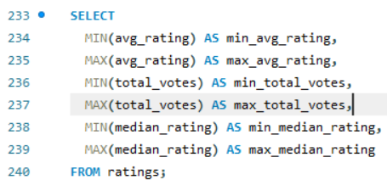



**x) Which are the top 10 movies based on their average rating?**

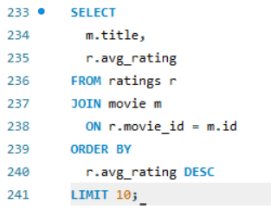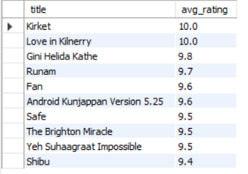

**xi) Summarize the ratings table by grouping movies based on their median ratings.**

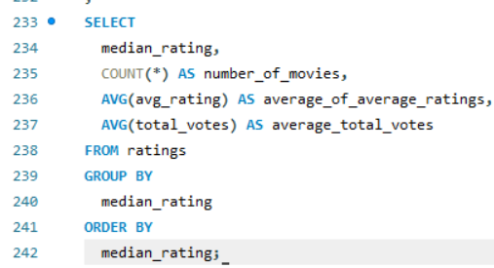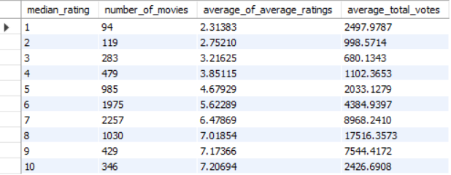

**xii) How many movies, released in March 2017 in the USA within a specific genre, had more than 1,000 votes?**

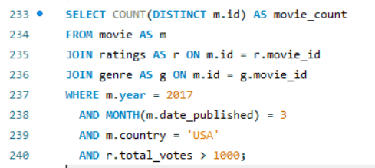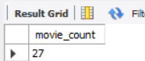

**xiii) Find movies from each genre that begin with the word “The” and have an average rating greater than 8.**

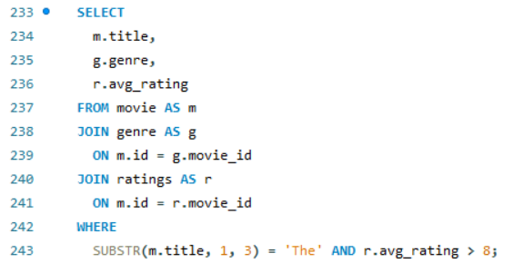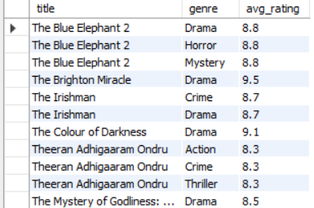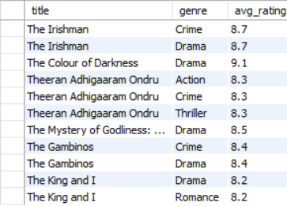

**xiv) Of the movies released between April 1, 2018, and April 1, 2019, how many received a median rating of 8?**

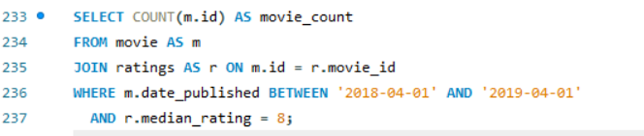

**xv)Do German movies receive more votes on average than Italian movies?**





**xvi)** **Identify the columns in the names table that contain null values.**

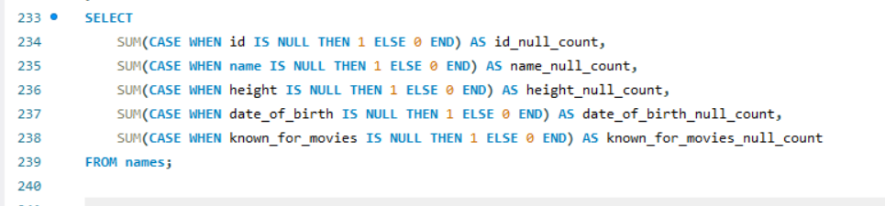

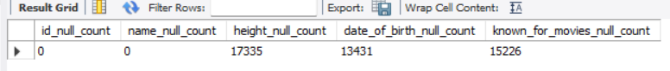

**xvii) Who are the top two actors whose movies have a median rating of 8 or higher?**

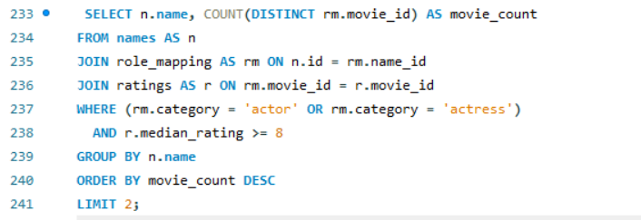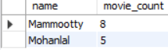

**xviii) Which are the top three production companies based on the total number of votes their movies received?**

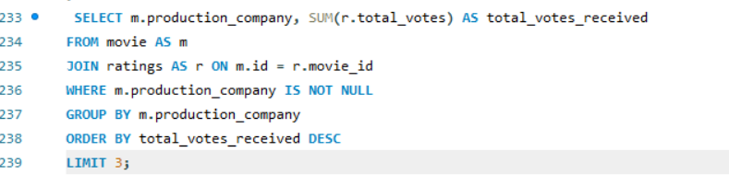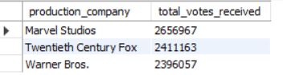

**xix) How many directors have worked on more than three movies?**

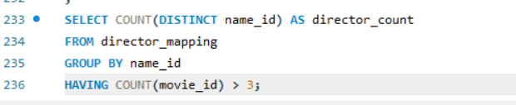

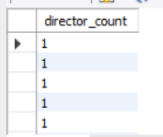

**xx) Calculate the average height of actors and actresses separately.**

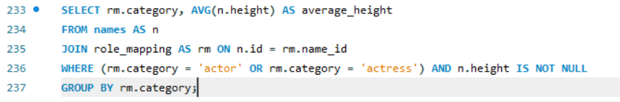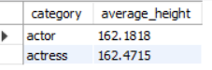

**xxi) List the 10 oldest movies in the dataset along with their title, country, and director.**

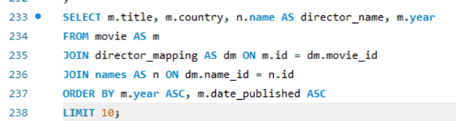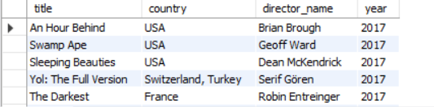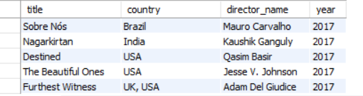

**xxii) List the top 5 movies with the highest total votes, along with their genres.**

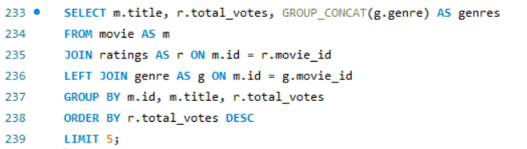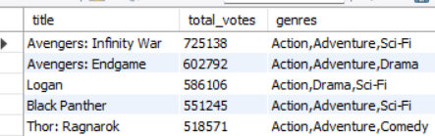

**xxiii) Identify the movie with the longest duration, along with its genre and production company.**

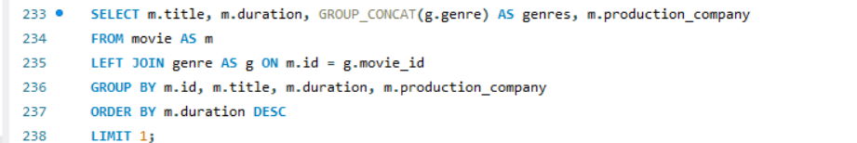

**xxiv) Determine the total number of votes for each movie released in 2018.**

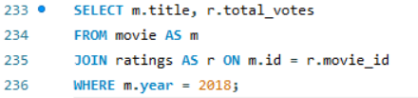

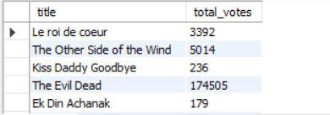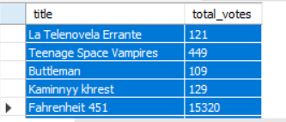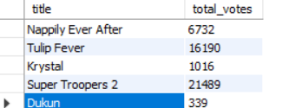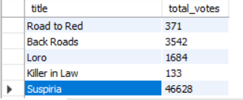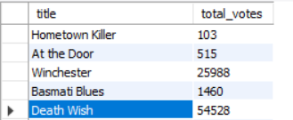

xxv) What is the most common language in which movies were produced?

